**Exercise 7: Packages**

* **Scenario 1:** Group all customer-related procedures and functions into a package.
* **Question:** Create a package ***CustomerManagement*** with procedures for adding a new customer, updating customer details, and a function to get customer balance.
* The `CustomerManagement` package specification defines a set of procedures and a function for managing customer data. It includes procedures for adding and updating customer records and a function to retrieve a customer's balance. This package provides an organized structure for handling common customer operations within the database.
* The package body implements these procedures by inserting and updating records in the `Customers` table and defines the logic for retrieving a customer's balance. Testing is performed using PL/SQL blocks to execute the `AddCustomer`, `UpdateCustomer`, and `GetCustomerBalance` methods. Verification includes outputting success messages and querying the `Customers` table to confirm that data modifications are correct and that the package functions as intended.

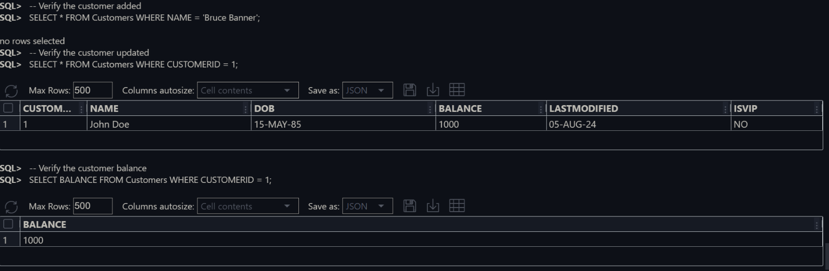**The OUTPUT :**

* **Scenario 2:** Create a package to manage employee data.
* **Question:** Write a package ***EmployeeManagement*** with procedures to hire new employees, update employee details, and a function to calculate annual salary.
* The `EmployeeManagement` package specification includes procedures for hiring and updating employees, along with a function to calculate an employee's annual salary. The `HireEmployee` procedure is implemented to insert new employee records into the `Employees` table, while the `UpdateEmployee` procedure updates existing employee details. The `CalculateAnnualSalary` function retrieves an employee's monthly salary and computes their annual salary, providing essential functionality for managing employee data.
* To ensure these operations work correctly, PL/SQL blocks are used to test the `HireEmployee`, `UpdateEmployee`, and `CalculateAnnualSalary` methods. Success messages are outputted, and queries on the `Employees` table are performed to verify that data modifications are accurate and the package functions as expected. This testing confirms that employee records are correctly added, updated, and that annual salary calculations are accurate.

**The OUTPUT :  
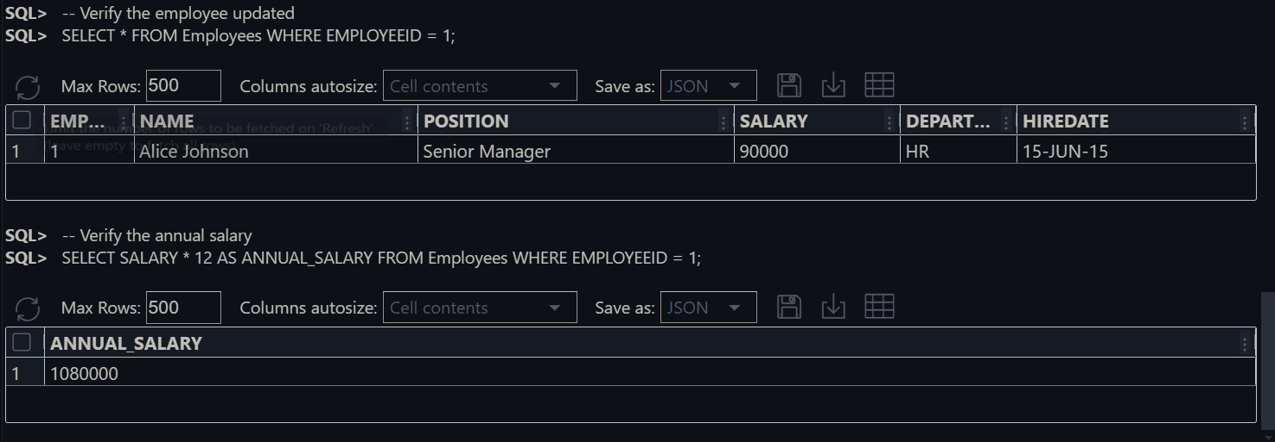**

* **Scenario 3:** Group all account-related operations into a package
* **Question:** Create a package ***AccountOperations*** with procedures for opening a new account, closing an account, and a function to get the total balance of a customer across all accounts.
* The `AccountOperations` package specification outlines procedures for opening and closing accounts and includes a function to retrieve a customer's total balance across all accounts. The `OpenAccount` procedure is responsible for inserting new account records into the `Accounts` table, while the `CloseAccount` procedure handles the deletion of account records, managing the lifecycle of accounts efficiently.
* The `GetTotalBalance` function is implemented to calculate and return a customer's total balance by summing the balances of all their accounts. This package provides essential operations for managing account data, ensuring that customers can efficiently open and close accounts while maintaining an accurate overview of their total financial standing across the accounts they hold.

**The OUTPUT:**